**Project Documentation:**

**Week 2 – Task 1:**

***E-Commerce Product Pages***

**Submitted By: Zara Khan**

**Submitted To: A&D Tech**

**Dated: 6st July, 2024**

***Main Page:***

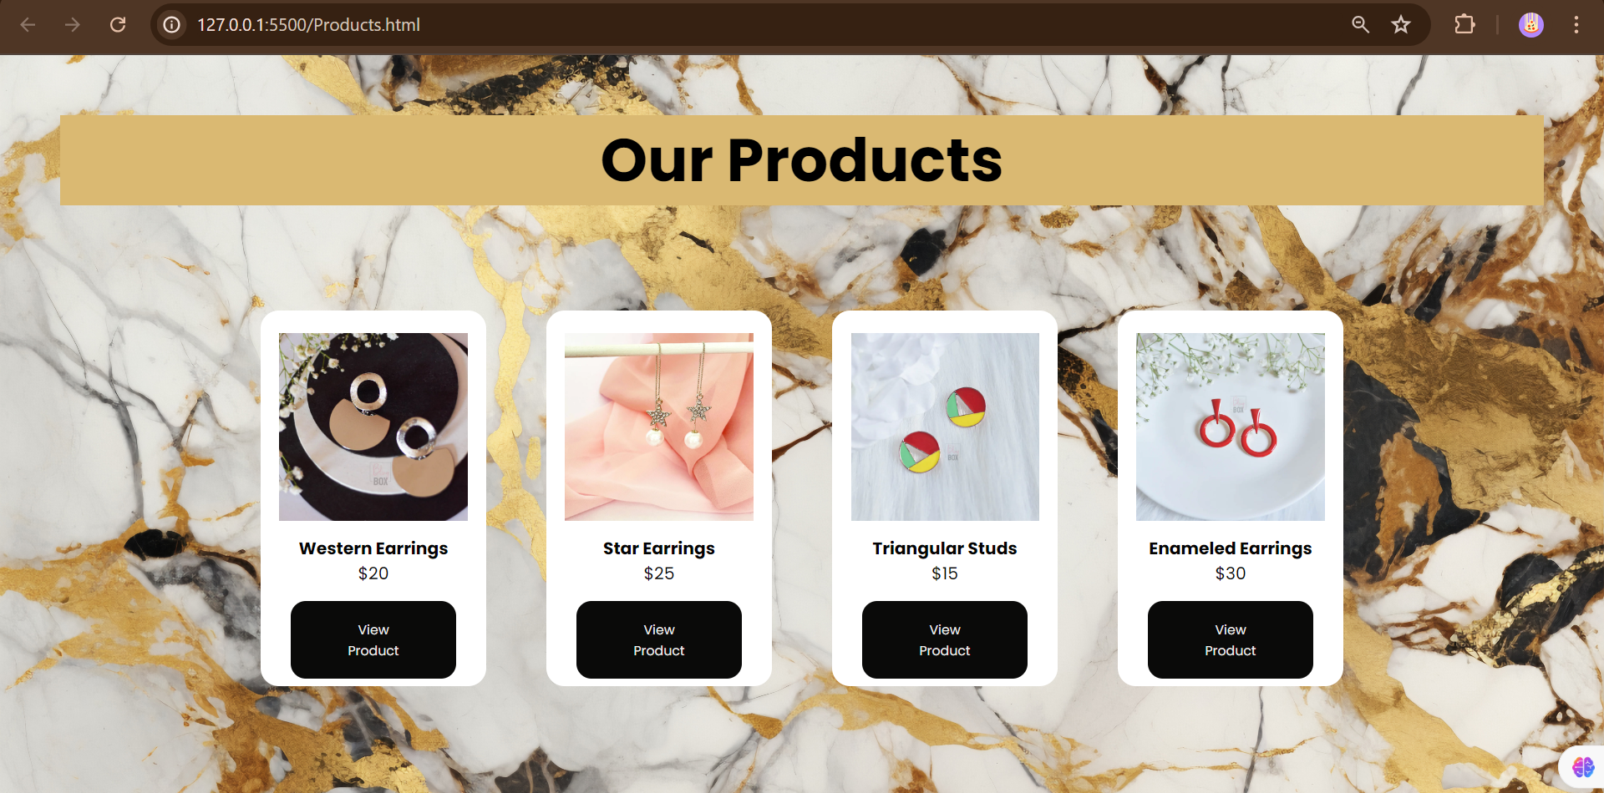

***Single Product Page:***

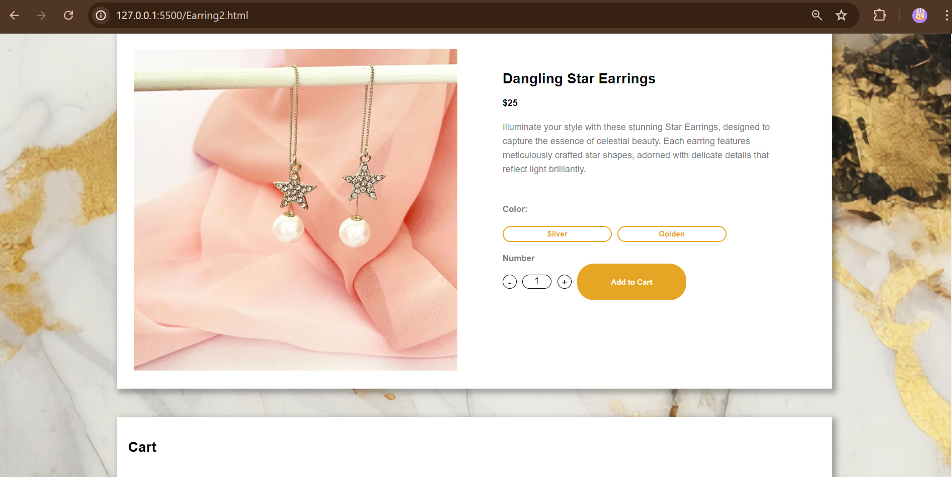

***Cart:***

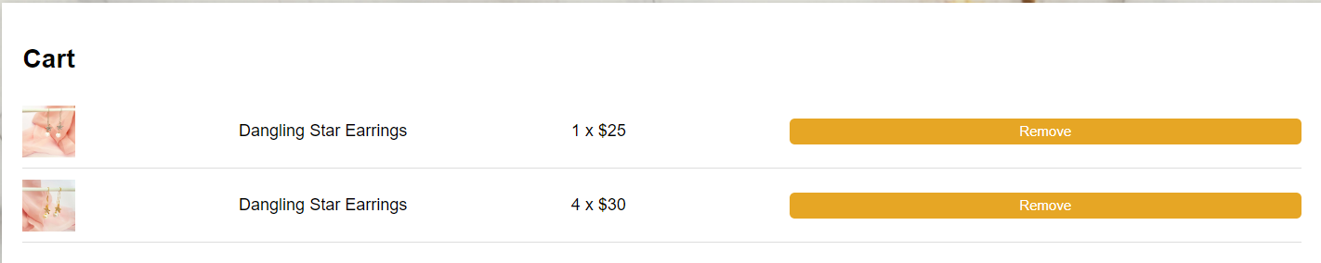



***Problem Statement***

Create a dynamic product page for an e-commerce website. This task will help you practice your layout skills, dynamic content loading, and handling user interactions.

***Solution Overview***

I approached the project by creating simple html product cards and adding links for their description pages.

***Challenges and Resolutions***

* **Challenge: Add to Cart Function**
* Add to Cart functionality implementation was the hardest. To add products according to users selection was a challenge.
* **Resolution:** Used JavaScript Functions to add and remove products from the cart and took help from online resources for this.
* **Challenge: Adding buttons**
* Adding buttons and ensuring they are responsive for all screens.
* **Resolution:** Using margin and padding properties of CSS to adjust.

***Instructions***

**Setting Up the Project**

1. **Download the Project Files:**
   * Clone the repository from [GitHub link].
   * Alternatively, download the project zip file and extract it to your local machine.
2. **Open in Visual Studio Code (VS Code):**
   * Launch VS Code.
   * Open the entire project folder using File > Open Folder.

**Running the Project**

1. **Navigate to the Main Page:**
   * In the VS Code sidebar, locate and open Products.html.
   * This file serves as the main entry point to the other pages.
2. **Exploring Other Pages:**
   * Each page provides details on different products from where you can check the ‘add to cart’ feature.
3. **Testing Responsiveness:**
   * Use VS Code's built-in preview or open the website in different browsers and devices to ensure responsiveness.